Analysis Report(SQL): Should Vendor37 Be Reopened?
Problem Summary:
In the world of Warframe, players engage in transactions to acquire various in-game items using real-world money. These transactions are processed by different vendors, each taking a certain percentage of the revenue. One significant vendor, Vendor37, was temporarily closed on April 1st due to external circumstances. This analysis aims to determine whether it's beneficial to reopen Vendor37 or keep it closed, based on a comprehensive examination of the data.
General Metrics
Proportion of Total Revenue
Before the closure, Vendor37 contributed to approximately 0.43% of the total revenue. When compared to the first 3 month’s revenue with respect to vendor37’s revenue contribution, it was around 0.74%. This proportion gives us an idea of Vendor37's financial significance within the game ecosystem.
Revenue per Day through Vendor37
Before the closure, Vendor37 generated an average revenue of $1938.86 per day which contributed to 0.7% of the total revenue generated per day ($265,445.52) with all vendors combined. This metric provides insights into the daily revenue performance of Vendor37.
Average Transactions per Day through Vendor37
Before the closure, Vendor37 generated an average revenue of 20 per day. This metric provides insights into the daily transaction performance of Vendor37.
Regional Usage Details
Vendor37 had significant usage across multiple countries, with varying revenue contributions:
- Top Countries by Usage: Country45 (950.82) Country66 (700), Country52 (605), etc.
- Lowest Countries by Usage: Country196 (0.0006), Country119 (0.03), Country180 (0.15), etc.

Regional Revenue Performance Details
Vendor37 had significant Revenue contribution across multiple countries, with varying revenue contributions:
- Top Countries by Revenue: Country66 ($10491128.76) Country45 ($9082617.73), Country16 ($2998857.82), etc.
- Lowest Countries by Revenue: Country196 ($2337.89), Country180 ($4691.07), Country6 ($4691.07), etc.

Upper Bound for Revenue Loss
The upper bound for revenue loss following the closure of Vendor37 was calculated to be approximately $6,841,203.04. This scenario helps us to understand the potential impact following the closure of Vendor37.
Affected Users
Around 0.04% (2913 out of 6977893) of the total users were expected to be affected by the closure of Vendor37.
Measurable Revenue Change
Comparing the transaction revenue before and after the closure on April 1st, we observed:
- Total Revenue before closure: $23,890,096.87
- Total Revenue after closure: $17,048,893.83
- Average Revenue per day before closure: $265,445.52.
- Revenue of APRIL 01: $255,652.71
- Average Revenue Per day drop after closure: $9792.81.
- This indicates a significant drop of 3.69% in revenue after the closure.

ARPU Comparison
The Average Revenue Per User (ARPU) of Vendor37 users after closure was 65.72 which is higher than other users' ARPU which was 54.35, after the closure. This indicates that a gap of 17.3% between the spending power of the users of Vendor37 in comparison to the spending power of users of other vendors.
User Migration
Around 8.07% (98 out of 1215) of Vendor37 users migrated to other vendors after the closure, indicating a limited shift.
Conclusion
Based on the analysis, it appears that reopening Vendor37 might be economically viable. While the proportion of total revenue and revenue per day through Vendor37 were notable, the closure resulted in a substantial revenue loss. Additionally, Vendor37 users still spent more in comparison to non Vendor37 users after the closure, and the user seemed to be loyal to Vendor37 due which we saw on 8% user migration. But there is a subsequent decrease as well in terms of spending power, suggesting that they found alternatives. However, the migration was relatively low, indicating that some users stuck with Vendor37's alternatives.
After running a Linear regression model on SQL, using the 1st 3 month’s dataset to analyse Vendor37 revenue pattern and other vendor’s revenue patterns, and used that to test on the next 3 months (4th, 5th & 6th month) dataset, the model forecasted a revenue of $517,860,357.68 if Vendor37 was not closed.
Overall, a cautious approach is recommended, considering the upper bound of revenue loss, forecasted revenue and the observable changes in user spending patterns.
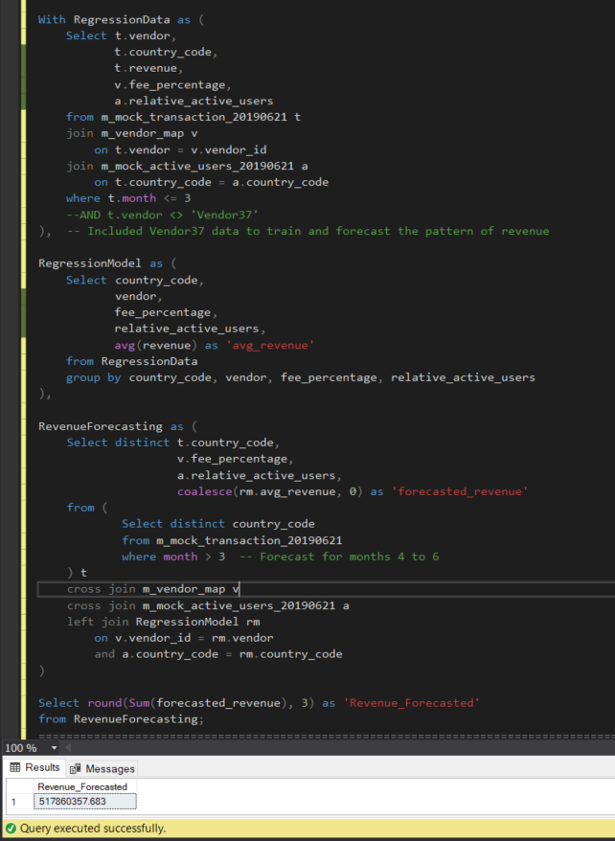
Note: Total time taken by the model to train and test the dataset is 48.50 mins.

